Jonathan Davis
******************
******************
******************
******************

23 November 2006

Dear Jonathan,

EDM 179 - Open Source

Thanks for your letter and for drawing this issue to my attention.

I will take on board the concerns you express about what appears to be a shortsighted approach from the DFES and I will seek an opportunity to raise it at Ministerial level. I will also make some enquiries of local authority colleagues in Tameside and Oldham to help my understanding of the potential impact on our local schools and educational institutions.

As an OU graduate myself I am always ready to back any initiative that recognises their splendid work. I will be signing the EDM as soon as possible.

Yours sincerely,
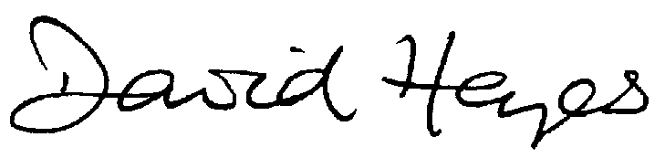
Member of Parliament
Ashton-under-Lyne

